# Plot

Choose Plot->Plot Data Settings

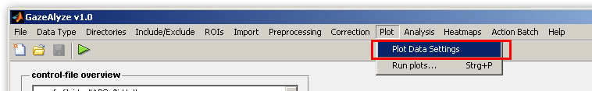

A new window will appear.

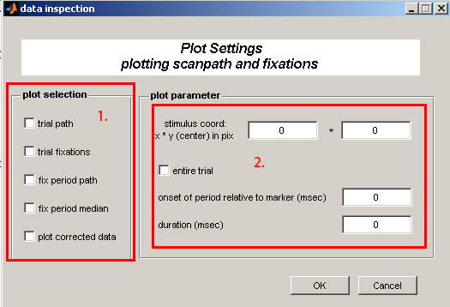

1. Select what shall be plotted.

2. If your stimulus coordinate system is not centered into the middle of the screen you can shift it by entering values here. If it is centered in the middle of the screen leave everything as it is.

Now you just have to select Plot-> Run plots and the plots will be generated.

